International Conference
DRAWING FROM TERRITORY -Research and Practices in Art, Science and Technology
Fundação Bienal de Cerveira and University of Porto
Vila Nova de Cerveira, Portugal
23rd-25th November 2026

Full text Guidelines
The main text should comprise between 4,000 and 5,000 words. The full paper must not exceed 20 pages, inclusive of all sections.
Abstracts must be 500 words in length. They should clearly outline the context, the identification of the research problem or topic, the methodology, and the main conclusions or findings. The abstract must not include footnotes, images, or figures. Submissions should follow the format and guidelines provided in the example on the following pages.

Upon submission of a paper, the authors implicitly warrant and declare that:
- They are the sole and exclusive holders of the copyright and bear full legal responsibility for the entirety of the paper.
- The paper is an original work, is not under simultaneous submission, and has not been previously published in any form.
- All statements of fact contained in the paper are true and accurate according to the current state of artistic and scientific research.
- The paper does not infringe any intellectual property rights or other rights of third parties.
- The paper contains no obscene, defamatory, or hateful material and does not include any form of hate speech.
- The paper does not infringe rights of privacy, publicity, or any other human, personal, or legal rights of any individual or entity, and is not otherwise unlawful.
- The paper does not breach any duty of confidentiality or violate any agreement, whether express or implied, entered into by the authors.
- All institutional, governmental, and/or other approvals required in connection with the practice, research, or reflective process underlying the paper have been duly obtained and remain in full force and effect.

Formatting Guidelines
Page margins: 3 cm.
Font: Aptos, size 12; no underlining, bold, or any other typographical emphasis.
Line spacing: 1.15; no spacing before or after paragraphs.
Text alignment: Justified.
Paragraph indentation: 1.5 cm first-line indent.
Title: Aptos, size 18; no underlining, bold, or any other typographical emphasis; centred alignment.
Keywords: Three to five keywords (“Keywords: ---; ---; ---; ---; ---”) placed immediately below the title, in Aptos, size 8; no underlining, bold, or any other typographical emphasis. Two blank lines (line spacing 1.15) must follow the keywords before the author identification.
Author identification: Aptos, size 8; line spacing 1.0; no underlining, bold, or any other typographical emphasis. Two blank lines must precede this section, equivalent to font size 12 with 1.15 line spacing.
Section headings: Aptos, size 14; no underlining, bold, or any other typographical emphasis; one blank line (equivalent to font size 12 with 1.15 line spacing) must be inserted before each subheading.
Quotations: Short quotations (fewer than three lines) should be enclosed in quotation marks (“ ”) and incorporated into the main text. Quotations longer than three lines must be set off from the main text and indented 5 cm from the left margin. Block quotations should be formatted in Aptos, size 10, with 1.0 line spacing, and without underlining, bold, or any other typographical emphasis. A spacing of 1.15 must be left between block quotations and the surrounding text.
Captions: Aptos, size 8; no underlining, bold, or any other typographical emphasis; 1.0 line spacing; no paragraph indentation. Captions should be placed below the corresponding figure or table.
Footnotes: Aptos, size 8; no underlining, bold, or any other typographical emphasis; 1.0 line spacing; no paragraph indentation.
Italics: Used for words in other languages, trademarks, institutions, book titles, and similar elements.
Images: Images must be centred and presented without text wrapping. Captions should be aligned to the width of the image and should begin after the figure reference (Fig. 1 – …; Fig. 2 – …). All images must be cited in the text. One blank line (equivalent to font size 12 with 1.15 line spacing) must be left above the image and one below the caption, separating it from the main text.
In addition to embedding images within the text, authors must also submit each image as a separate digital file (TIFF or JPEG format, with a resolution of 300 dpi).
Where applicable, authors must provide the conference organisers, together with the submitted paper, with written permission from the respective copyright holders for the use of any images included in the text.
Tables and graphs: Tables and graphs must be centred and presented without text wrapping. Captions should be aligned to the width of the table or graph and should begin after the table/graph reference (Tab. or Graph 1 – …; Tab. or Graph 2 – …). All tables and graphs must be cited in the text. One blank line (equivalent to font size 12 with 1.15 line spacing) must be left above each table or graph and one below the caption, separating it from the main text.
Tables and graphs must be original and provided in vector format.
Where tables or graphs are derived from other sources, authors must provide the conference organisers, together with the submitted paper, with written permission from the respective copyright holders, where required.
References: Aptos, size 8; line spacing 1.0; no underlining, bold, or any other typographical emphasis; 1.15 cm paragraph indentation; justified alignment. Two blank lines (equivalent to font size 12 with 1.15 line spacing) must precede the references. References must follow APA, 7th edition (APAstyle or bibme)

Title
Keywords: Keyword; Keyword; Keyword; Keyword; Keyword

Autor¹ (Surname, Given name); Autor² (Surname, Given name); …
¹⁾ Full name of primary affiliation, full name of secondary affiliation, e-mail address
²⁾ Full name of primary affiliation, full name of secondary affiliation, e-mail address
…

Abstract
[Text (x500)]
Text Text Text Text Text Text Text Text Text Text Text Text Text Text Text Text Text Text Text Text Text Text Text Text Text Text Text Text Text Text Text Text Text Text
(…)
Text Text Text Text Text Text Text Text Text Text Text Text Text Text Text Text Text Text Text Text Text Text Text Text Text Text Text Text Text Text Text Text Text Text

Main body of the text
[Text (x4000 a x5000)]
Text Text Text Text Text Text Text Text Text Text Text Text Text Text Text Text Text Text Text Text Text Text Text Text Text Text Text Text Text Text Text Text Text Text Text Text “Quotation” Text Text Text
Text Text “Quotation Quotation Quotation Quotation” Text Text Text Text Text Text Text Text Text Text Text Text Text Text Text Text Text Text Text Text Text Text Text Text Text Text Text Text Text Text Text Text Text Text Text Text Text Text Text Text Text Text Text Text Text Text Text Text Text Text Text Text Text Text Text Text Text Text Text Text Text Text
Text Text Text Text Text Text Text Text Text Text Text Text Text Text Text Text Text Text Text Text Text Text Text Text Text Text Text Text Text Text Text Text Text Text Text Text Text Text Text Text Text Text Text Text Text Text Text Text Text Text Text Text Text Text Text Text Text Text Text Text Text Text Text Text Text Text Text Text Text Text Text
Text Text Text Text Text Text Text Text Text Text Text Text Text Text Text Text Text Text Text Text Text Text Text Text Text Text Text Text Text Text Text Text Text Text Text Text Text Text Text Text Text Text Text Text Text Text Text Text Text Text Text Text Text Text Text Text Text Text Text Text Text Text Text Text Text Text Text Text Text Text Text Text Text Text Text Text Text Text Text Text Text Text Text Text Text Text Text Text Text Text Text Text Text Text Text Text Text Text Text Text Text Text Text Text Text Text Text Text Text Text Text Text Text Text Text Text Text Text Text Text Text Text Text Text Text Text Text Text Text Text Text Text Text Text Text Text Text Text Text Text Text Text Text Text Text Text Text Text Text Text Text Text Text Text Text Text Text Text Text Text Text Text Text Text Text Text Text Text Text Text Text Text Text Text Text Text Text Text Text Text Text Text Text Text Text Text Text Text Text Text Text Text Text Text Text Text Text Text Text Text Text Text Text Text Text Text Text Text Text Text Text Text Text

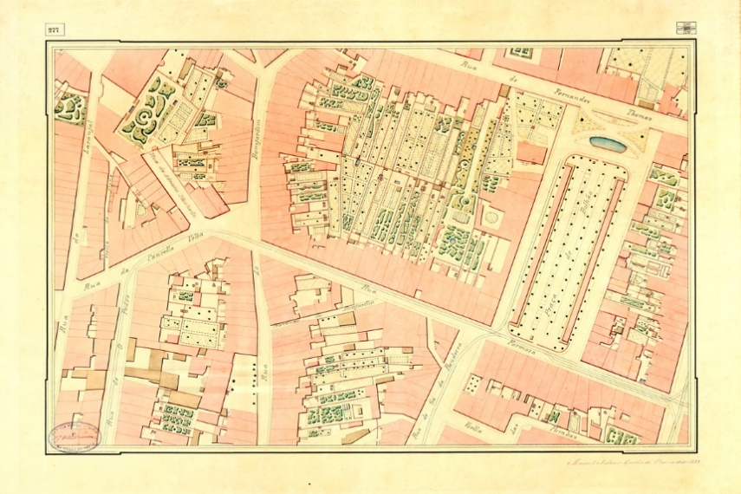
Fig. 1 – Sheet xxx of the Telles Ferreira Map. Source: … [included in the reference list of this paper]

Text Text Text Text Text Text Text Text Text Text Text Text Text Text Text Text Text Text Text Text Text Text Text Text Text Text Text Text Text Text Text Text Text Text Text Text Text Text Text Text Text Text Text Text Text Text Text Text Text Text Text Text Text Text Text Text Text Text TeText “Quotation Quotation Quotation” Text Text Text Text Text Text Text Text Text Text Text Text Text Text Text Text Text Text Text Text Text Text Text Text Text Text Text Text Text Text Text Text Text Text Text Text Text Text Text Text Text Text Text Text Text Text Text Text Text Text Text Text Text Text Text Text Text Text Text Text Text Text

“Quotation Quotation Quotation Quotation Quotation Quotation Quotation Quotation Quotation Quotation Quotation Quotation Quotation Quotation Quotation Quotation Quotation Quotation Quotation Quotation Quotation”.
(Author’s surname, year of publication, page number(s))

Text Text Text Text Text Text Text Text Text Text Text Text Text Text Text Text Text Text Text Text Text Text Text Text Text Text Text Text Text Text Text Text Text Text Text Text Text “Quotation Quotation Quotation Quotation Quotation” Text Text Text Text Text Text Text Text Text Text Text Text Text Text Text Text Text Text Text Text Text Text Text Text Text Text Text Text Text Text Text Text Text Text Text Text Text Text Text Text Text Text Text
(…)
Text Text Text Text Text Text Text Text Text Text Text Text Text Text Text Text Text Text Text Text Text Text Text Text Text Text Text Text Text Text Text Text Text Text Text Text Text Text Text Text Text Text Text Text Text Text Text Text Text Text Text Text Text
Text Text Text Text Text Text Text Text Text Text Text Text Text Text Text Text Text Text Text Text Text Text Text Text Text Text Text Text Text Text Text Text Text Text Text Text Text Text Text Text Text Text Text Text Text Text Text Text Text Text Text Text Text Text Text Text Text
Text Text Text Text Text Text Text Text Text Text Text Text Text Text Text Text Text Text Text Text Text Text Text Text Text Text Text Text Text Text Text Text Text Text Text Text Text Text Text Text Text Text Text Text Text Text Text Text Text Text Text Text Text Text Text Text Text Text Text Text Text Text Text Text Text Text Text Text Text Text Text Text Text Text Text Text Text Text Text Text Text Text Text Text Text Text Text Text

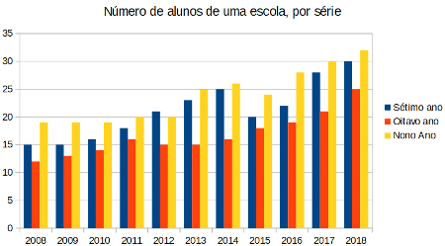
Graph 1 – Register of students. Source: … [included in the reference list of this paper].

Text Text Text Text Text Text Text Text Text Text Text Text Text Text Text Text Text Text Text Text Text Text Text Text Text Text Text Text Text Text Text Text Text Text Text Text Text Text Text Text Text Text Text Text Text Text Text Text Text Text Text Text Text Text Text Text Text Text Text Text Text
Text Text Text Text Text Text Text Text Text Text Text Text Text Text Text Text Text Text Text Text Text Text Text Text Text Text Text Text Text Text Text Text Text Text Text Text Text Text Text Text Text Text Text Text Text Text Text Text Text Text Text Text Text Text “Quotation Quotation Quotation” Text Text Text Text Text Text Text Text Text Text Text Text Text Text Text Text Text Text Text Text Text Text Text Text Text Text Text Text Text Text Text Text Text Text Text Text Text Text Text Text Text Text Text Text
Text Text Text Text Text Text Text Text Text Text Text Text Text Text Text Text Text Text
Text
Text Text Text Text Text Text Text Text Text Text Text Text Text Text Text Text Text Text Text Text Text Text Text Text Text Text Text Text Text Text Text Text Text Text Text Text Text Text Text Text Text Text Text Text Text Text Text
Text Text Text Text Text Text Text “Quotation Quotation Quotation” Text Text Text Text Text Text Text Text Text
Text Text Text Text Text Text Text Text Text Text Text Text Text Text Text Text Text Text Text Text Text Text Text Text Text Text Text Text Text Text Text Text Text Text Text Text Text Text Text Text Text Text Text Text Text Text Text Text Text Text Text Text Text Text Text Text Text Text Text Text Text Text Text Text Text Text Text Text Text Text Text Text Text Text Text Text Text Text Text Text Text Text Text Text Text Text Text Text Text Text Text Text Text Text Text Text Text Text Text Text Text Text Text Text Text Text Text Text Text Text Text Text Text Text Text Text Text Text Text Text

References
1. Reference
2. Reference
3. Reference
(…)

Footnote Footnote Footnote Footnote Footnote
Footnote Footnote Footnote Footnote Footnote Footnote
Footnote Footnote Footnote Footnote Footnote Footnote
Footnote Footnote Footnote Footnote
Footnote Footnote Footnote Footnote Footnote Footnote Footnote Footnote Footnote Footnote Footnote Footnote Footnote Footnote Footnote
Footnote Footnote Footnote Footnote Footnote

